**NOISE POLLUTION MONITORING**

**MICROPHONE SENSOR**

**PHASE 2**

**DEFINITION:**

* A microphone sensor helps an electronic product capture sound waves and convert that energy into electrical energy.
* So it can be processed and used in application such as voice recognition in smart speakers, mobile phones and smart watches. 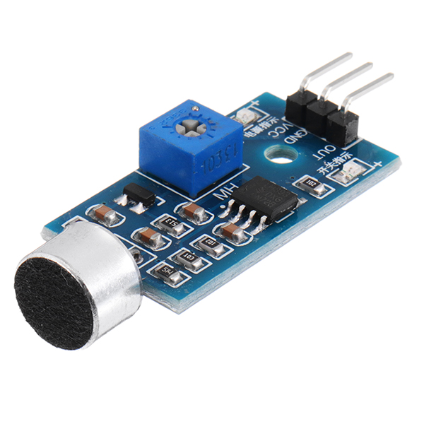

**ARDUINO UNO**

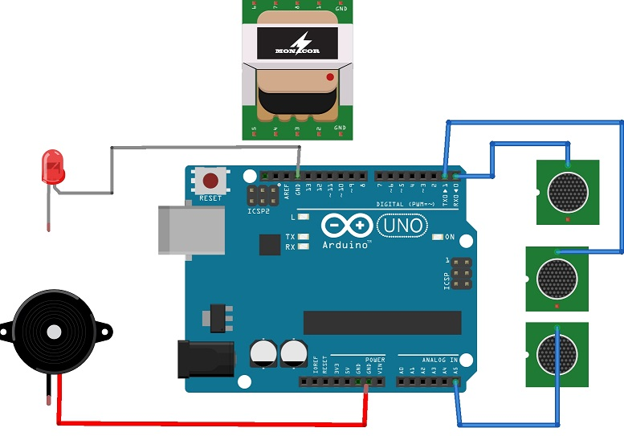

* It is a micro controller board based on the ATmega328P.
* “Uno” means one in Italian and release of Arduino software 1.0.

**BLOCK DIAGRAM OF MICROPHONE SENSOR**

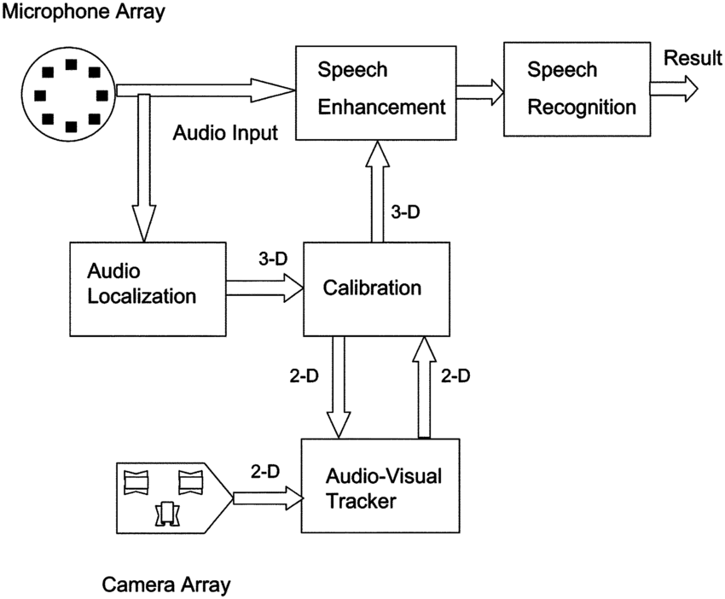

Microphone: It provides audio inputs to the speech enhancements and audio localization modules.

Audio localization: Three dimensional localization estimates are generated by the audio localization module, which are mapped onto the corresponding 2D image plane by the calibration module.

Audio visual tracker: It process the 2D information along with the visual information from the camera array to track the active speaker.

Calibration: The 3D estimates are reconstructed by the calibration module from two camera views, which are input to the speech enhancement module.

Speech enhancement: The enhanced speech from the module which is composed of a beam former followed by a post filter.

Speech recognition: It is used as a input to the speech recognition module.

**SPECIFICATIONS**

* Wide operating voltage of 3.3V to 5V DC.
* LM393 comparator with threshold present is used.
* High sensitivity of 1 KHz
* Microphones dB level of 52 to 48 dB.
* Operating current of 4 mA to 5mA.
* The induction distance is 0.5 meters.

**WORKING PRINCIPLE**

T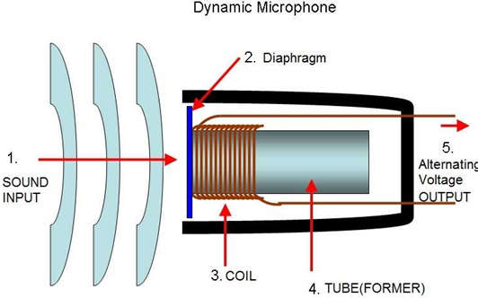

* The microphone has an inbuilt diaphragm, made up of magnets which are coiled by metal wire.
* Whenever sound wave hits the diaphragm, magnets vibrate and at the same time coil induces the current.

**APPLICATIONS**

The following are the microphone sensor applications,

* Used in sound pressure level devices.
* Spy , security and monitoring systems such as door and burglar alarms.
* Communication devices like mobile phones, laptops, robotics.
* Audio amplifiers, sound level, record the audio and ambient sound recognition systems.

**SENSOR INTERFACING WITH ARDUINO**

The circuit diagram of the interfacing microphone sensor with arduino is shown below,

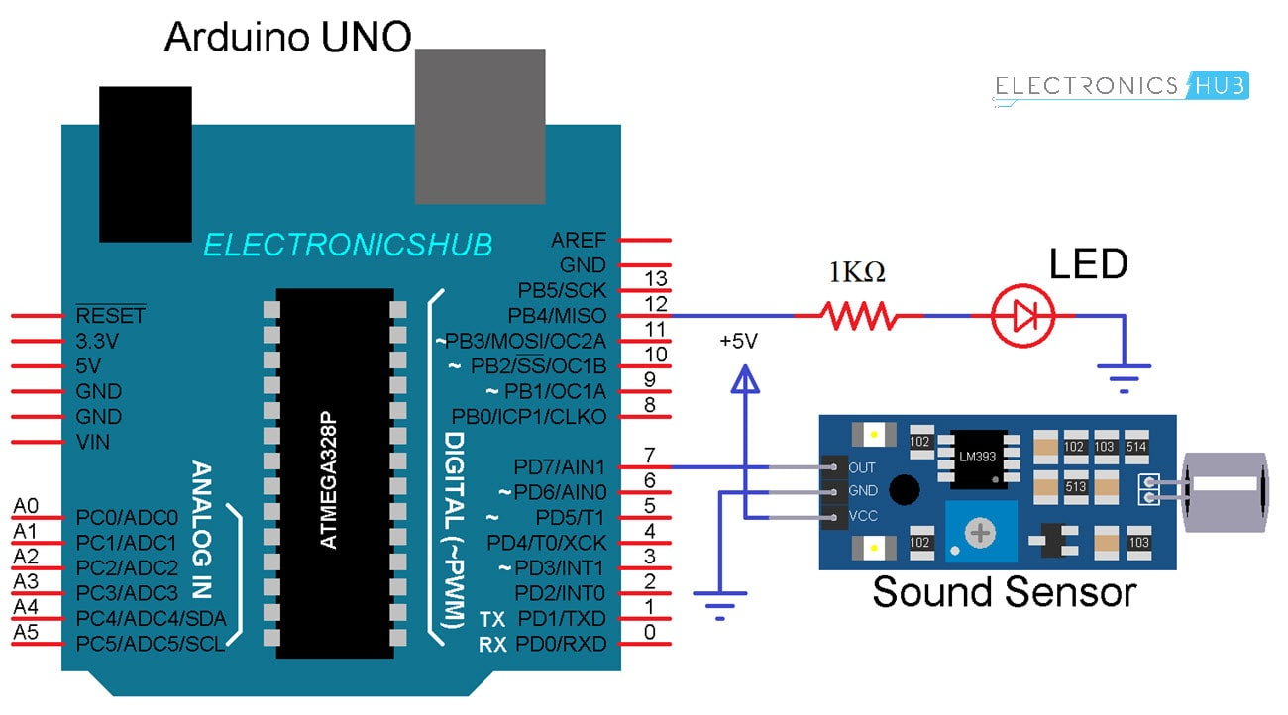

* Sound sensor module
* Arduino UNO
* LED
* Resistor kilo Ohms
* Mini bread board
* Connecting wires

**ADVANTAGES**

* It is suitable for security systems and speech recognition.
* It is faster than manual typing.
* Very easy in sound manipulation in real time applications without any requirement of earlier recordings.
* Wireless sound sensor are easy to handle and do not required cable.

**DISADVANTAGES**

* More memory size is required to store sound files.
* Microphone sensors based on voice recognition software are inaccurate.
* Wireless microphones are used for only a limited range.